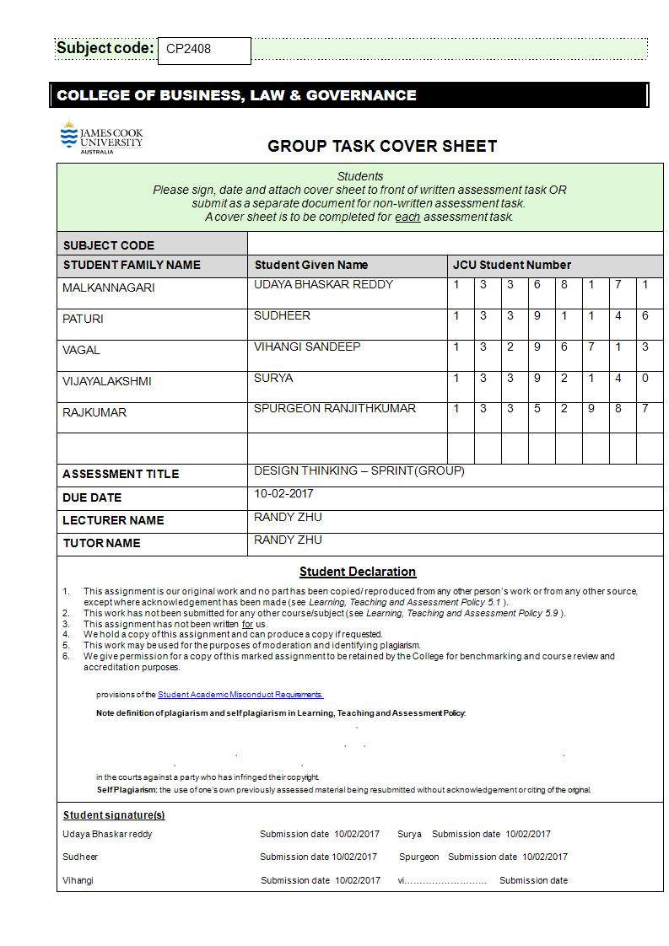

**Challenge:**

**In the recent years there is a significant increase in e-commerce sales. Platforms such as amazon, Ez-buy, Qoo10 and redmart are becoming mainstream for online shoppers. The increase in e-commerce sales also leads to the increase in delivery service however it is costly to engage a fixed delivery provider and there are also a number of delivery providers that do not provide quality service.**

**Your team is a start-up company looking at using disruptive technology to change how delivery services function today. Use the lean UX approach to find a solution that allow ecommerce platform to engage your delivery services easily at a lower cost.**

**Summary of the Design thinking process:**

**Choosing the Challenge:**

The e-Commerce revolution has turned the “traditional” supply chain on its head. From the speed of delivery, to the increased expectations for the delivery experience, this change has in large part been driven by the more empowered consumer of today. However, it is in the last-mile that many of the challenges manifest.

The challenges that many suppliers encounter boil down to the delivery of goods and services. Are the goods reaching on time? Are there any delays or damages? Are they secure enough to enhance customer trustworthiness? Can the cost of delivery be kept under control? Is there a chance for a frictionless delivery to the customers? Can there be an open communication channel between the suppliers and the customers to ensure a safe and prompt delivery of the product?

So many questions plague the minds of the suppliers who are involved in these businesses. Dealing with these challenges requires investing in a solution that helps businesses manage their deliveries. Before taking up this challenge, our team has discussed about the issue at large and how it is affecting the consumer world. We did some basic research to understand the key issues the e-commerce businesses are facing. So many issues came up during our group discussion. First, we tried to look at the issue from the perspective of the delivery men involved. As we are a new start up delivery company, we looked at **the problems that we may encounter in the progress of our business**. Can we make adequate changes to the existing delivery system? What are the existing norms that make the delivery system efficient? What are the reasons for the discrepancies in the existing system? Can the implementation of new disruptive technologies help improve its efficiency? These are some of the questions we used as a starting point of our initial research.

Upon conducting further research, we tried to identify who our target users are. **We believed that addressing the issue from a retailer perspective can streamline the whole process into a more functional arrangement.** By solving the problems faced by the retailers, we are essentially solving the core issues involved in the whole delivery process. As a start-up delivery service, it is of paramount importance for us to cater to the needs of the retailers. Our main goal was to implement changes in technology so that we can fill in the existing gap in the commerce world, and at the same time make the overall process cost effective and efficient.

The long term goal and the basic project questions are explained in the section below.

**Long term goal:**

The long term goal of this project is to allow retailers of e-commerce platforms engage in product delivery services easily in a cost effective manner by changing the existing trends in the current technologies available in the market.

**Project Questions:**

Our team participated in multiple brainstorming sessions. We came to the conclusion that we will analyze the core issues a retailer would face in delivering their goods.Our research was retailer-centric. We put ourselves in the users shoes and analyzed the day to day problems they face. Here are some of the problems that we identified with the existing methods used in delivery services. It includes a list of problems that the users encounter while delivering a certain product. The users, as mentioned above, are the retailers who want their product delivered to the customers.

1) Vehicle break downs during transportation resulting in the delays of delivery.

2) Hard to transport fragile goods.

3) Can’t keep track of the delivery schedules.

4) Issues regarding misplaced goods and lost pick ups

5) Making reliable and fast delivery.

6) Maintenance of goods and services.

7) Monitoring the delivery services for prompt deliveries.

8) 24/7 delivery. Deliveries to made at odd hours and challenges of last minute orders and late time deliveries.

9) Proper human resources for onboard and reliable employees.

10) Capacity of deliveries based on the size of the goods.

11) Price changes during the order process – taxes, shipping costs.

12) Deliveries not reaching the customers on time.

13) Delivery getting late during peak seasons due to overwhelming demand.

14) Payments methods of the customers. Delay in payments by the customers.

After creating a list of project questions, we created a project map that helped us layout the summary of all the issues a retailer faces. The map acted as a guiding tool for us to identify the key issues in a single frame and helped us in connecting the solution with the problem. Our end goal was to create a cost effective method of delivery, but our immediate goals comprise of winning our user confidence in a step by step manner. The project map helped us identify the path towards these goals. It was a way of understanding our relationship with the customers. It was a way of defining the problem our customers are facing, that is, the discrepancies in the delivery of goods. Our team realized be a lot of brainstorming stages involved in reaching our end goals, but our primary purpose was served by identifying the correlation between our user and the problems they were facing. The means of addressing may vary depending on the approach we take further in this work, but our initial goal was fulfilled with the help of the project map.

The project map is displayed below. The stakeholders are represented on the left hand side.

**Stakeholders/Players:**

Retailers

Delivery Services

**Retailer issues**

More cost effective means of delivering a product

More efficient ways of delivery

**Goal:**

Create a new system that is cost effective, efficient and retailer-friendly.

**Project Map:**

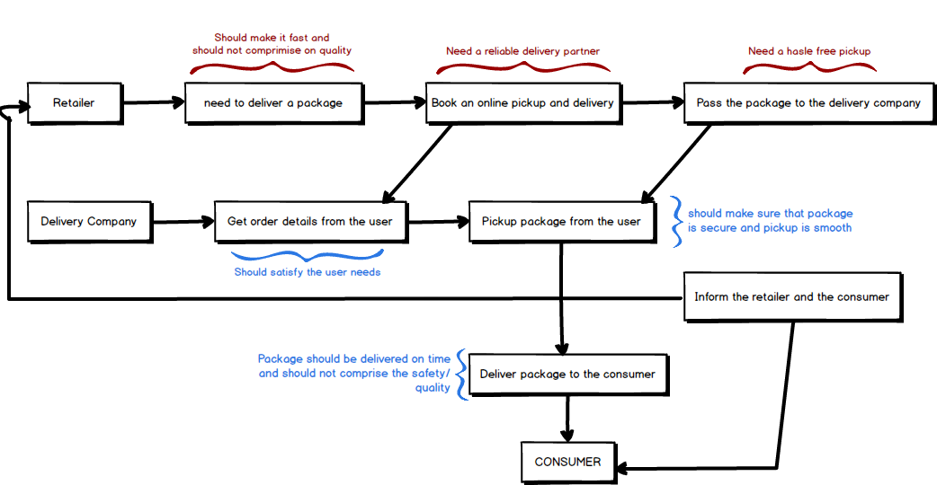

**Declaring Assumptions**

After creating the project map, we understood the way the whole system functions. We have to identify the core issues that our users face in delivering goods. For that, our primary tool was again placing ourselves in the user’s shoes. This has always been a much needed step in the whole design thinking and lean UX process. Our team came up with a list of assumptions about the services that we have to incorporate in our product. A lot of online research was required at this stage. We had to ensure that our assumptions were not entirely baseless and had a strong support within the context of the issues the retailer faces. We had to double check our assumptions with our team mates as well. This initial phase of our project was a critical part, as any misstep here would result in the failing of the whole project. The significance of the lean UX methods came to the fore during this phase because it gave us the option to validate our assumptions and hypothesis with the users directly. This gave us the opportunity to analyze even the smallest of the issues that plagued our users.

The assumptions we came up with are listed below.

**Assumptions:**

1. Users have access to internet.

2. Users wants to receive notifications regarding the status of the package.

3. Users want the delivery to be fast and reliable.

4. User want the delivery to be delivered anytime of the day.

5. User want to fix a delivery time and want it to be made on time.

6. User wants the option to know when their product is delivered.

7. Users may want to track the package.

8. Users have the knowledge to make payment online.

9. Users have a valid credit/debit card.

10. Users are willing to wait for the estimated period of time for the delivery.

11. Users are willing to pay shipping cost.

12. Users are willing to pay tax for delivery items.

13. User may want the transaction to be made in local currency.

14. User want all sized products to be delivered.

15. User wants a refund if the product is damaged or not delivered.

16. User wants to get feedback from the consumer after delivery.

17. Users are willing to accept new methods and technologies for delivery.

**Outcomes:**

After creating the list of assumptions, we focused on the outcomes and the hypothesis that enables us to test the assumptions. We used the Lean UX format of table during this process. We identified the outcomes in the form of key performance indicators. We also created 3 proto-personas, that is explained in the sections below.

**1)**The use of new technologies like Drone-delivery can effectively reduce the costs of .delivering goods when compared to using manpower. This will be a direct result of the reduction in the number of employees which include the vehicle drivers.lt also reduces the cost of buying a large number of vehicles for the transport of goods.

**Key Performance Indicator:**

This metric can be measured by checking the overall revenue spent on the drone technology over a period of six months and comparing it with the revenue spent on buying vehicles and paying employees for the transportation of goods and maintaining its services.

**2)** The retailers prefer to receive feedbacks from the customers after their deliveries are made. This will act as a resourceful feedback to the retailers. They can ensure if the goods are delivered on time and if the customers had any further complaints with the quality of the goods delivered.

**Key Performance Indicator:**

This metric can be measured by conducting quarterly surveys of the retailers regarding the feedbacks they receive from the customers.

**3)**The retailers want to make urgent deliveries at all times of the day. This allows them to have an edge in the market and boost their standing with respect to their competitors.

**Key Performance Indicator:**

This metric can be measured by analyzing the statistical data of the delivery times over a period of six months. This will indicate the number of urgent deliveries that were made. And by comparing this data with the number of bookings by the same retailers over the same period of time. If the bookings increase, it implies that the retailer was successful in winning the customer confidence.

**4)**The retailers want their deliveries to be fast and reliable, and the goods be delivered in good condition. This will increase the credibility of the retailer with the customer along with improving the standing of the delivery service company in the eyes of the retailer.

**Key Performance Indicator:**

This metric can be measured by analyzing the number of continued orders from the same retailer in a specific period of time of six months. It can be checked by analyzing the successful delivery of goods made for the retailer in the stipulated amount of time.

**Hypothesis:**

Herein, we explain the hypothesis for all the assumptions we have made in the previous section.

1. **Assumption: Users have access to internet**

We believe that have users have access to internet, and making a website would be beneficial for the users so that they can make a delivery booking in a seamless and easier way. This would result in more number of people using our website.

This can be measured by the increase in the usage of the website based on the web stats.

2. **Assumption: Users want to receive notifications regarding the status of the package.**

We believe that users want to receive notifications regarding the status of the package via e-mail/SMS. This would result in user being aware of the package status.

This can be measured by the volume of messages/emails sent to the user.

**3.** **Assumption: Users want the delivery to be fast and reliable.**

We believe that users want the delivery to be fast and reliable. This would result in the satisfaction of the users’ desire to send the package as fast as possible.

This can be measured through the feedback given by the user, regarding the delivery speed of the package.

**4.** **Assumption: Users want the delivery to be made anytime of the day.**

We believe that user wants the delivery to be deliveries during any time of the day, this would result in satisfying the convenience need of the user regarding time of the day.

This can be measured through checking the number of deliveries made during all times of the day.

**5.** **Assumption: Users want to fix a delivery time and want it to be made of time.**

We believe that user wants to fix a delivery time and want the delivery to be made on time, this would enhance the user's credibility with the consumer.

This can be measured by the feedback given by the user, regarding the on-time delivery of the package.

**6.** **Assumption: Users want to know when their product is delivered**

We believe that user wants to know when their product is going to be delivered, this would result in user knowing the delivery status of the package.

This can be measured through the completion rate of the deliveries.

**7.** **Assumption: Users may want to track the package**

We believe that users may want to track the package, this will help in user knowing the location of the package.

This can be measured by the percentage of interest shown by the users in the package tracking system.

**8.** **Assumption: Users have the knowledge to make payments online.**

We believe user have the knowledge to make a payment online, this would result in an increase in the number of online transactions.

This can be measured through the percentage of online transactions made.

**9.** **Assumption: Users have a valid credit/debit card.**

We believe that users have a valid credit/debit card, this would result in an making payments through card payment options.

This can be measured through the percentage of payments done through credit/debit cards.

**10.** **Assumption: Users are willing to wait for the estimated period of time for delivery.**

We believe that users are willing to wait the estimated period of time required for delivery, this would result in a quality delivery process for the user.

This can be measured through analyzing the delivery time schedules.

**11.** **Assumption: Users are willing to pay the shipping cost.**

We believe that users are willing to pay shipping cost, this would result in delivery of goods in a faster pace.

This can be measured through the increase in percentage of payments received for shipping costs.

**12. Assumption: Users are willing to pay the tax.**

We believe that users are willing to pay tax for delivery items, this would result in delivery of goods to foreign countries.

This can be measured through the percentage of international transactions made.

**13.** **Assumption: Users may want the transactions to be made in local currency.**

We believe that users may want the transactions to be made in local currency, this would result in the user catering to the consumer's convenience.

This can be measured by the percentage of cash payments done upon delivery.

**14.** **Assumption: Users want all size of products to be delivered.**

We believe that user wants all types of size of products to be delivered, this would result in the delivery of all the kind of goods user wants to deliver.

This can be measured through analyzing the size of the packages delivered.

**15.** **Assumption: Users want a refund if the product is damaged or not delivered.**

We believe that the user wants a refund if the product is damaged or not delivered, this would result in delivery service credibility with the user.

This can be measured by analyzing the refunds made for delivery.

**16.** **Assumption: Users want to get feedback from the consumer upon delivery**

We believe that user wants to get feedback from consumer upon delivery, this would result in the trustworthiness of the user.

This can be measured by the consumer feedback on the website.

**17 Assumption: Users are willing to use new technologies and methods for efficient delivery.**

We believe that users are willing to accept new methods of delivery for efficiency, this would result in the delivery of products in a cost effective and efficient way.

This can be measured by analyzing rate of delivery options chosen by the user.

**Interview Questions:**

1) Do you use the internet for your services?

2) Do you want your deliveries to be quick? Are you willing to wait for an estimated amount of time for the deliveries to be made?

3) Is there a need for a faster and reliable service for your delivery?

4) Is there a need for odd-hour deliveries? Do you get orders for late time deliveries from the customers?

5) Do you want a fixed delivery time for your packages?

6) Are there any transportation issues you encounter with the delivery services?

7) Are there any issues of damaged or lost goods while delivering the products?

8) Do the services refund you if the goods are damaged or lost? Do they insure your goods?

9) Do you wish to track the status of the goods while they are delivered to the customers?

10) What is the mode of payment you prefer? Do you want the customers to pay beforehand online or do you give the option to make cash payments?

11) Do you accept all kinds of currency from your customers?

12) Do you wish to receive feedbacks from your customers?

13) Are you willing to pay the shipping costs for the delivery?

14) Do you pay the taxes on foreign goods in case of international deliveries?

15) Do you need to make bulk deliveries in a stipulated amount of time?

16) Are you interested in using new methods and technologies in delivering your goods, for example use drones for quicker and efficient transfer?

17) Do you think innovations in technology can make deliveries more cost-effective?

**Proto personas(Retailers):**

**Persona 1:**

Name: Richard

Age: 45 years

Nationality: British

Profession: Retailer with amazon

In the retailer business for 15 years. Has a good reputation with the customers for providing quality services.

Specializes in international transactions.

Has a wide experience in dealing with many delivery service companies in Singapore.

Appreciates the use of new technologies for efficient delivery of goods.

**Persona 2:**

Name: John

Age: 36 years

Nationality: Chinese

Profession: New retailer with qoo10

New to the retailer business.

Specializes in local transactions.

Minimal experience when dealing with delivery service companies. Facing losses in his new work ventures.Needs advice for choosing a good delivery service to boost up his profits.

Is open to new technologies if they are cost effective.

**Persona 3 (Outlier):**

Name**:** Sebastien

Age: 25 years

Nationality: Indonesian

Profession: Working student doing MBA.

A normal user using the e-commerce websites to sell his products. Looking for faster ways to deliver the goods. Reliability of the product can be an issue as the user is not a professional retailer.

Cannot afford to have a fixed delivery service considering the costs involved to engage one.

Has no knowledge of the technologies involved in delivering goods.

**Problem Statement:**

We have observed that the current delivery service providers are not meeting with certain criteria that retailers would consider for the delivery of their goods. These criteria include a more cost effective means of delivery, more reliability and new technologies that enhance the efficiency of the current delivery system. We want to solve this problem by offering quality delivery service that uses new disruptive technology like “Drone-delivery” by making it more cost effective to the retailers.

**Features:**

* **E-COMMERCE SITE LINK:**

· Letting the user link his/her account directly to an e-commerce site, so that all their order details on their e-commerce site will be updated to this delivery site upon placing an order and can be used for the delivery of the package.

* **PLACE ORDER:**

· **Choose a pickup service -** Drone “or” Person

· Letting the user choose a prefered pickup service based on the package size and weight.

· **Choose a delivery option -** Drone “or” Person

· Letting the user choose a delivery service based on the package size and weight.

· **Choose a pickup/delivery time**

· Letting the user choose a preferred pickup/delivery time

· **Number of items to be delivered**

· Giving option for the user to make a bulk delivery of items.

* **ONGOING ORDERS:**

· The user can check all the ongoing orders that are yet to be delivered, and also details regarding the pickup time, estimate time for delivery and a button for tracking a particular delivery will be included.

* **RECORDS:**

· A history of all the orders made by the user are included in this tab, this will include all the details including delivery times, pickup time, cost of delivery, feedback and everything will be made available to the user.

* **TRACK PACKAGE:**

· Allows the user to track the status of the package by inputting the tracking id, and a map will be displayed to the user, with real time tracking enabled.

* **PAYMENT OPTION:**

· A list of payment options will be given to the user to choose from and input details. For example,in credit card option, the user can upload all his/her card details. Options like Android Pay, Apple Pay will also be included.

**STORYBOARD:**

Based on the proto-personas we created our team came with a storyboard that explains the issues our users are facing and the solutions we offered. We used both the fictional characters that we created as a reference for understanding the relevance of the issue. Richard is an experienced retailer who knows the workings of the system well enough. John is a new retailer trying to learn the tasks of the trade. The conversation explains the problem john is facing and how richard helps him to solve it.

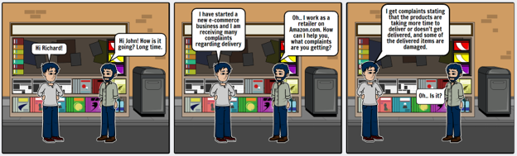

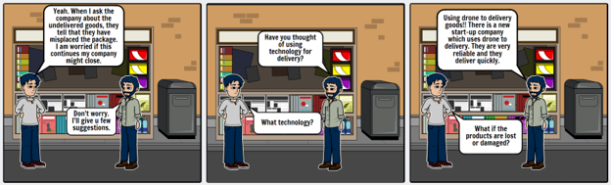

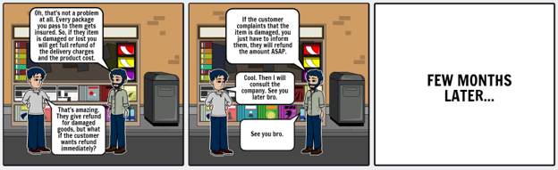

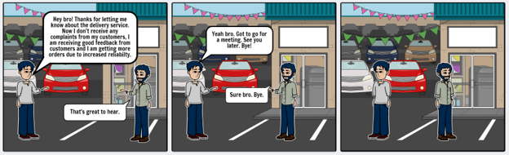

**Interviews - Insights and Stories**

Our interviewees were students assuming the role of retailers and trying to give us feedback on our assumptions and design choices. We conducted three interviews and the user reflections are given below. The actual interview transcripts are available at the end of the document in the appendix.

**Participant 1**

**Personal details**:

Name : Sanjay Kumar

Gender: Male

Age : 20

Course : Bachelor of information technology

Location: taken in campus

Interview Date: 8th Feb 2017

Interview Time: 13:30

**Interesting stories**:

The student is thinking from the retailer’s point of view. The student feels that there shouldn’t be any fixed delivery times as it may not serve as a convenient option to customer who are working for long hours. Moreover, he also suggests that the goods must be constantly tracked to keep him and the customer updated. He also prefers online transactions as he believes it easier to keep a record and easier for the customers. He also believes that if the customer opts for a bulk order than he can exempt the customer from shipping costs.

**Motivations**:

He feels that he hasn’t received any damaged goods due to the proper maintenance of supply chains. He is also satisfied with the instant refund facility which he receives when a damaged good is delivered and moreover he ensures the delivery of quality products. He is motivated by customer feedback which he feels is the main commodity and informs him whether the product delivered is according to customer's’ expectations.

**Frustrations**:

He is not satisfied with the delivery service. The deliveries take a lot of time and are not fast and reliable. He also faces transportation issues while delivering the good. He feels he needs to monitor the packages, pay all the drivers and those are additional shipping costs.

**Interactions:**

He feels that there is no requirement of delivery at odd hours or late night. He feels that’s a wastage of cost and incurs additional shipping costs. He wants to increase the trust relation with the customer and hence would want to include cash on delivery if necessary. He would also expect all kinds of currencies to make the customer relationship stronger. He also feels that introducing new technology is a disadvantage as it increases the investment and later the maintenance costs.

**Participant 2**

**Personal details**:

Name : Kevin

Gender: Male

Age : 21

Course : Bachelor of information technology

Location: taken in campus

Interview Date: 8th Feb 2017

Interview Time: 13:40

**Interesting stories**:

The student is answering from the retailer’s point of view. He feels that the current services provided for delivery are not very helpful. They are not accurate. They deliver products to the wrong address and the time is a major constraint. He also prefers to have a fixed time for delivery depending on the service provider. This enable all the goods to be delivered on the estimated time. He prefers time from 18:00 – 20:00 as at this time all the working people will reach at home. He also would want keep a track of the goods and orders made. He also suggests a strategy to cover the shipping costs, i.e., include the shipping cost in the marked price.

**Motivations**:

He did not face any problem during transporting the goods. In case of rare situation where the goods were damaged he received an immediate refund. He also only delivered quality products which satisfied the customers. He was motivated by the constant feedback he received from the customer. The feedback included the remarks on the quality and delivery of the product.

**Frustrations**:

He often felt that he had to wait for a long time to deliver a few products. He was also unhappy because the situations where in the customer wanted to return a product, the customer had to send it to the required postal code, and the extra charges has to paid by the customer. He felt that this was a negative impact on the customer relationship. He also preferred online transactions over cash on delivery. He felt that cash on delivery included a lot of risks and he cannot accept all currencies. He was also not willing to pay the shipping costs.

**Interactions:**

He felt that delivery of products at odd hours or late nights is a disturbance for the customer itself and hence should not be included. He also felt that there must some solution for fast deliveries for bulk orders. He also felt that technologies, like drones could act as a fast and efficient mode of delivery.

**Participant 3**

**Personal details**:

Name : Wei Ching

Gender: Female

Age : 19

Course : Bachelor of information technology

Location: taken in campus

Interview Date: 8th Feb 2017

Interview Time: 14:00

**Interesting stories**:

She is answering most of the question from the retailer’s point of view. She believes that fixed delivery timings in not a necessary constraint. She is willing to pay international shipping costs as she believes it a part of the law. She has not encountered bulk deliveries.

**Motivations**:

She has seen her customers being satisfied with faster delivery and if required willing to wait for a few days if the product is being internationally shipped. She also feels it’s a necessity to monitor the goods which are being delivered. She also feels the feedback from the customer keeps her updated.

**Frustrations**:

She has encountered customers who have been shipped wrong products and she is unable to refund the whole price. She has also encountered customers whose goods have been lost during delivery. She also come across situation where in there is no one to receive the product. All the problems she has encountered is during transportation and delivery.

**Interactions:**

She feels that delivery at odd hours is not required. She prefers online payment. She feels that cash on delivery will be a hustle for the customer, as the customer may have to go and withdraw cash. In addition, it will be very inconvenient to keep a track of the transactions. Moreover, online transactions can accept all currencies. She also feels that implementing the drone technology will be cost effective but at the same time we must ensure security and that the products are not damaged. Moreover, the drones must be trackable.

**Team Collaboration:**

● **Team Configuration**:

Team Leader: Uday

Team Members: Sudheer

Spurgeon

Vihangi

Surya

Uday

● **Team Approach**: After discussing among ourselves on which topic to choose, we selected the challenge. We started with sharing our ideas about the project and how we should approach it, the ways, the means and the rules of the approach. We divided the work based on the strengths identified during the previous assignments.

● **Communication**: Most of the team communication is done through Whatsapp , Email and google keep. We decided to use Whatsapp as the preferred communication method as it is the best available option for the interoperability of the team. During each step, we noted down ideas and inputs of each team member on google keep which was shared by all the members.

● **Information sharing:** We constantly updated the file with the new information and points we discussed during the meetings. We decided Google keep would be the best cloud sharing option as it can synchronize data in real time even if all the team members are using it all at the same time.

● **Team Progress:** We divided our work equally and assigned tasks which were performed collaboratively.

● **Conflict Management:** When working in a team, a conflict is inevitable. We as a team had some conflicts among ourselves, but we got through that phase and are working towards achieving our set goal. Most of the conflicts are regarding an idea or a topic that some of the team members cannot agree upon, or cannot fully understand. These are mostly debates among ourselves. And turned out to have a positive impact. We observed that after the conflict was resolved we would think and approach the problem from a different perspective. A new way of thinking is the first step towards innovation. It will also help us achieve our goals in a competitive manner. Our team leader tries to explain the question more and clear, in such a way that it will reduce the tension in the group and also helped us focus.

**Prototype and Testing - Iteration 1**

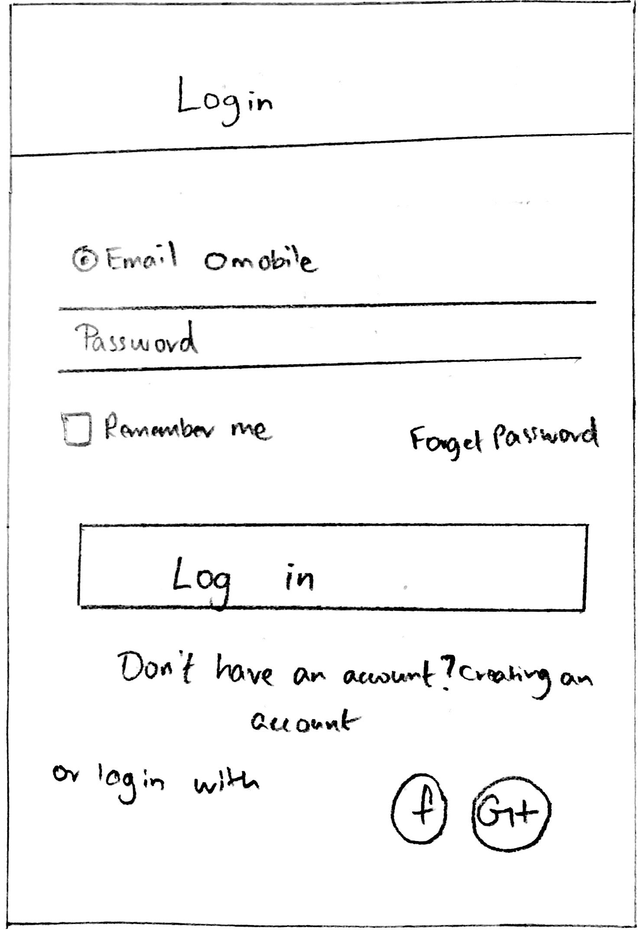

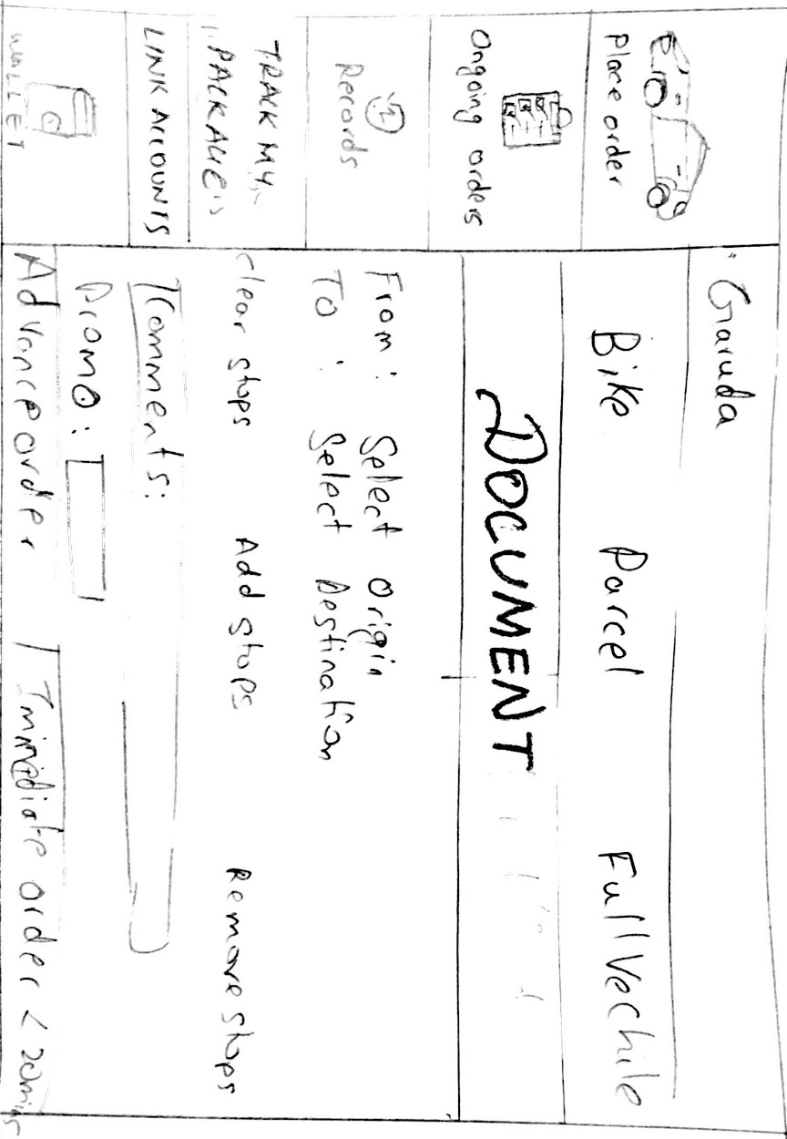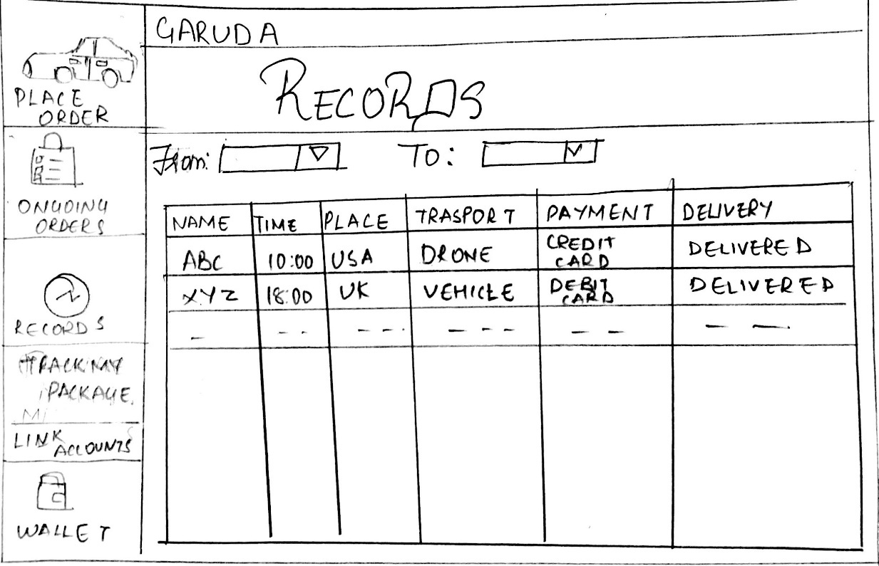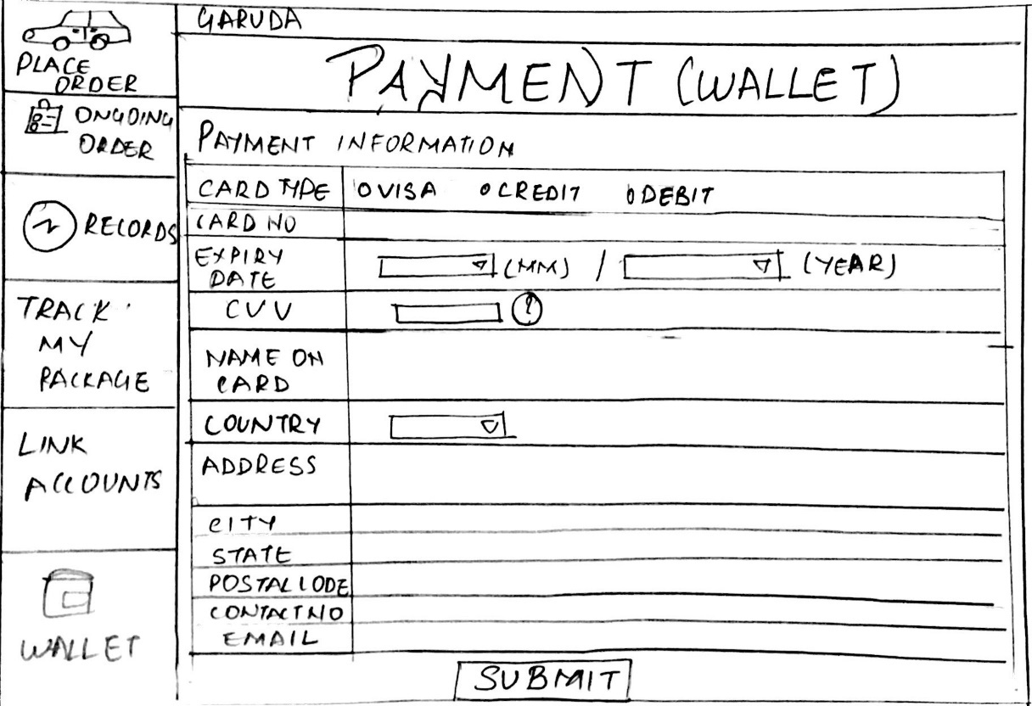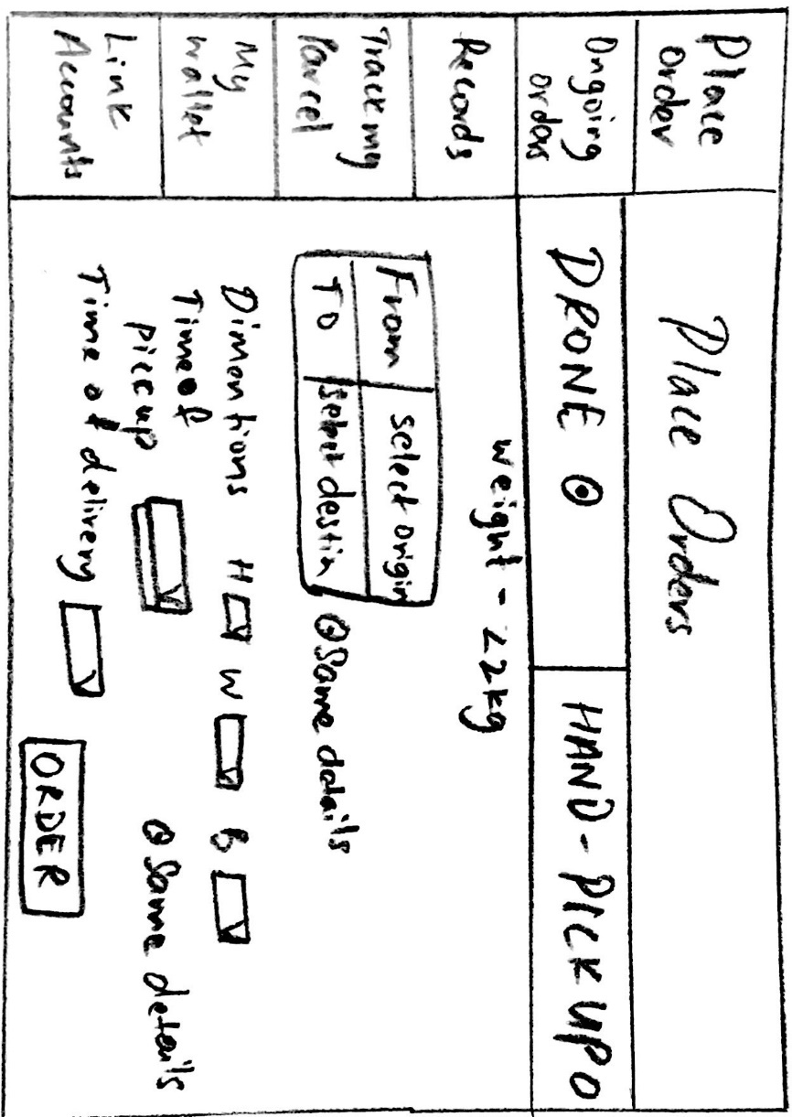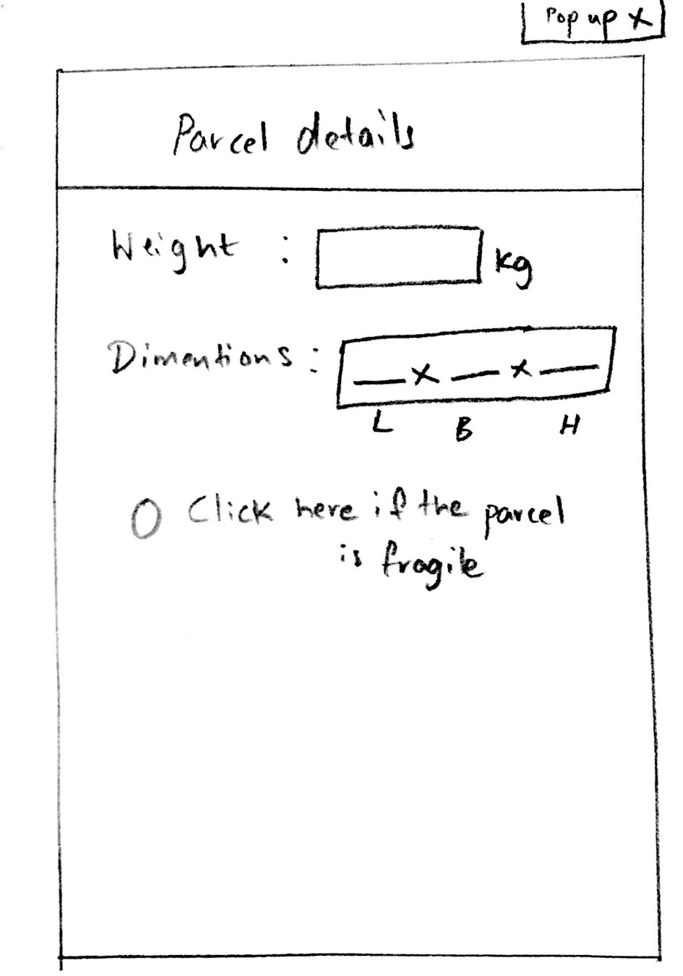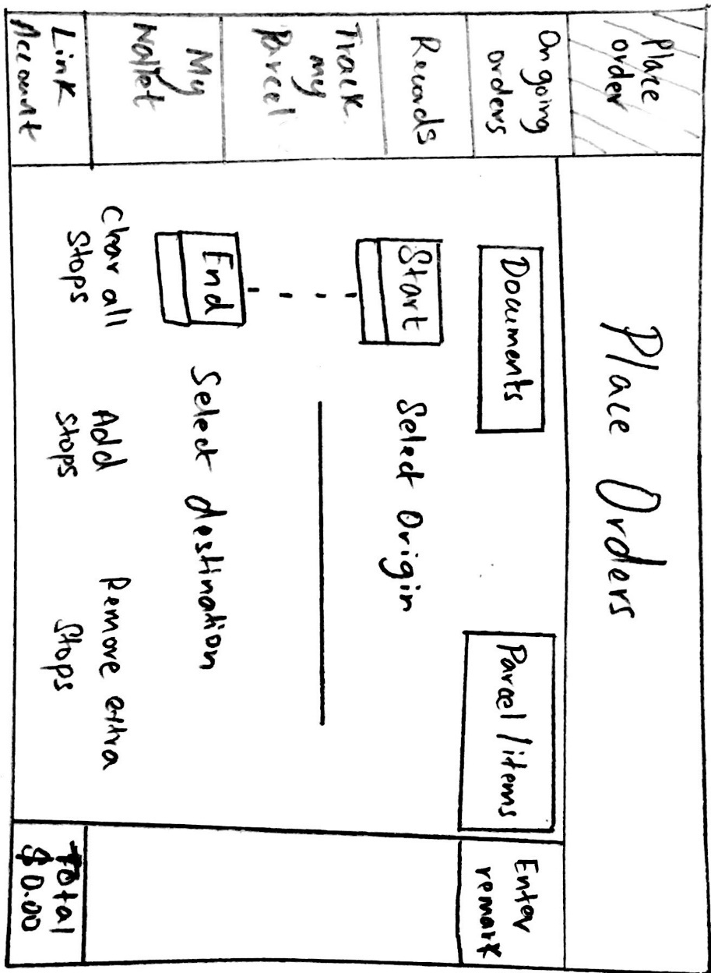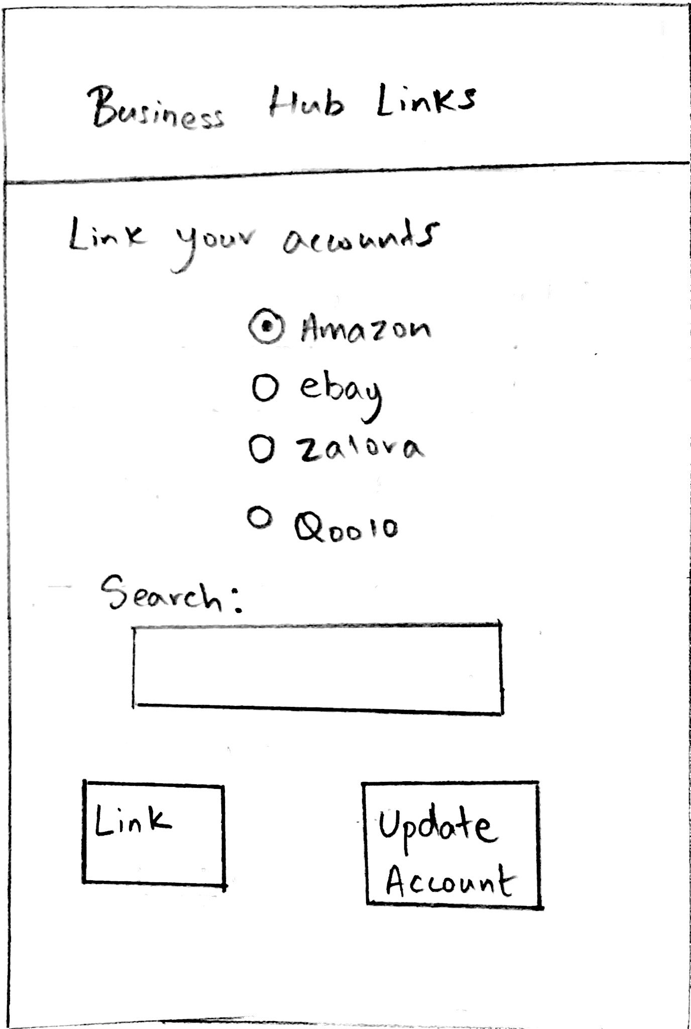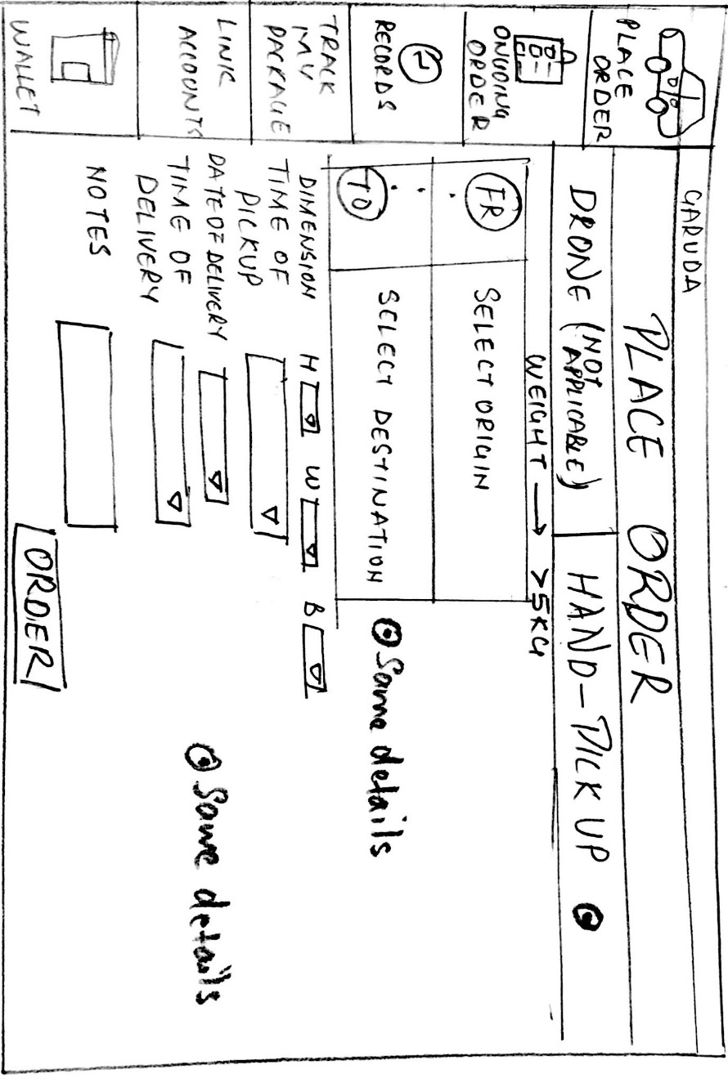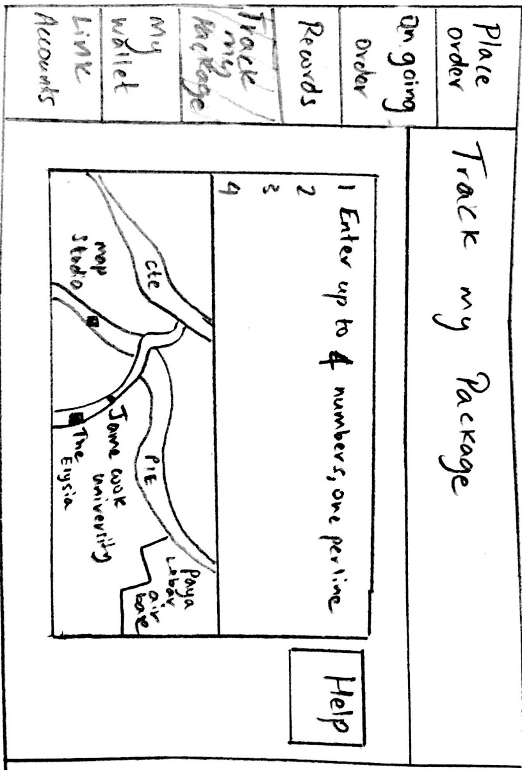

The first prototype was mainly used as a means of validating the features incorporated in the product. These features were based on the assumptions we made with regard to the interests of the retailers. Since this iteration was made as paper drawings,it provided a chance for us to make immediate changes.We concentrated on delivering the maximum features possible during this iteration. The focus was more about features and less about the actual design of the website.The users were in line with our thought and gave us consistent feedback with regard to the features of the product. This example signifies the effectiveness of the lean UX method of going back to the user to refine our product. It is a time saving concept wherein the user essentially becomes a part of the whole development process.

**Testing**

Conducted three user testings on the first iteration by showing the user the prototype and requesting them to use it. The user suggested a few things based on the iteration. Some of the user’s had concerns regarding the login page about option of contact info of the retailer. Most of the user’s had problem understanding the categories section of the order placement page. Some users had doubts about where a particular page is being linked to. The tracking feature also raised some concerns with some users regarding the vague design of the page. Most of the troubles or concerns the users had were regarding the “place order” page. Users were also concerned that there was no option to provide feedback for improvements to be made.

**Insights:**

1. The user needs a better understanding of the features of the website. This can be achieved through improving the design of the site.
2. The delivery details column needs to be improved.
3. Scroll down menus need to be added.
4. Tracking the package page needs improvement and should be designed keeping simplicity as the main objective.
5. Login page should be redesigned for providing a better sign-in experience to the user.
6. The biggest concern was the “place order” page of the website, this needs to be completely redesigned and all the features need to be improved.
7. Users liked the link e-commerce account option.

**Changes to the next prototype**

1. A complete overhaul of the design is needed. So, moving on from paper to digital prototype and also making a new design for each page and feature of the website.
2. Adding a new login page and also a register page, to enter all the contact details of the user.
3. Adding scroll down functionality to some pages, for a better user experience.
4. Making sure that all pages are linked properly to their counterparts for a seamless experience.
5. A new “Track my package” page with a simplified interface and tracking button will be designed.
6. A “feedback” page will be added for the users to provide feedback regarding any issues they have with the online booking or drone pickup/delivery among other things.
7. All the other pages will be redesigned as well but they will have an almost similar functionality.

**Some of the things that we would like to add to the insights:**

***What did the participants value the most?***

The participants valued the link e-commerce feature the most in this iteration. The feature to link their online e-commerce account directly with the delivery service seemed to be most liked feature.

***What got them excited?***

They were excited about the new technology which was introduced. The drone was considered to be efficient and a faster mode of transport.

***What would convince them about the idea?***

The idea about delivering the package on the convenience of the customer and tracking the package convince the user. Moreover, the constant feedback they received will help them understand how efficient the delivery was. Moreover, delivery of packages with the help of drones will cut down on shipping costs and hence attract more customers.

The following pages were added/modified after the first iteration.

**Prototype and Testing - Iteration 2**

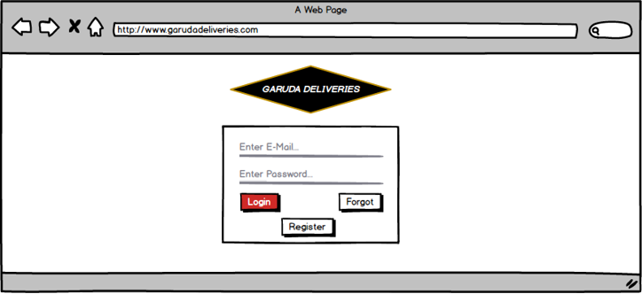

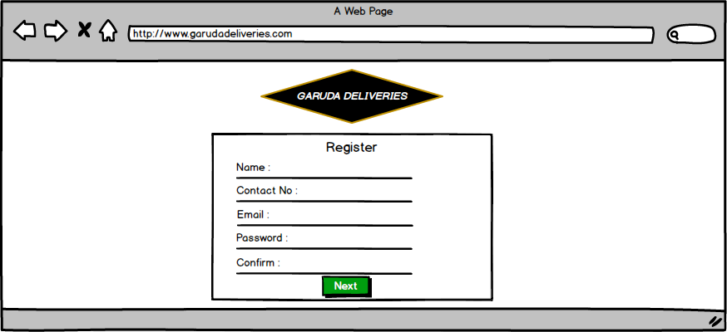

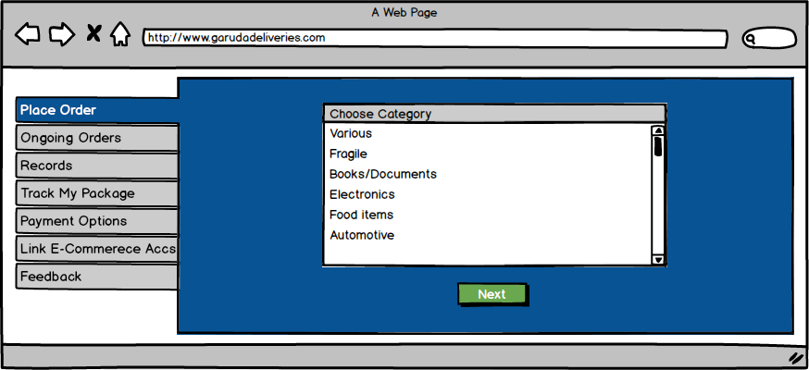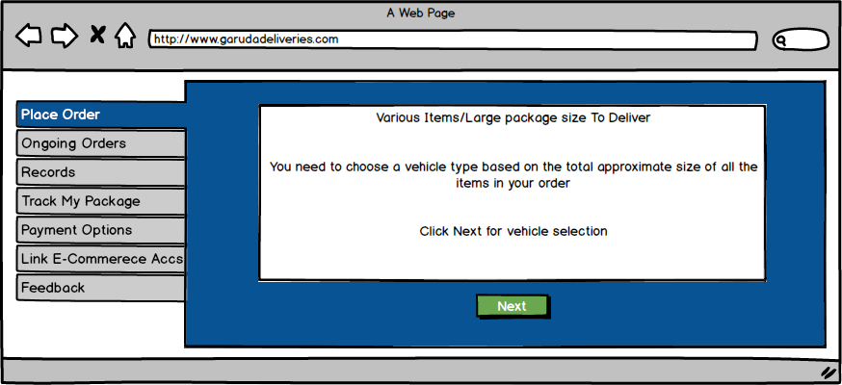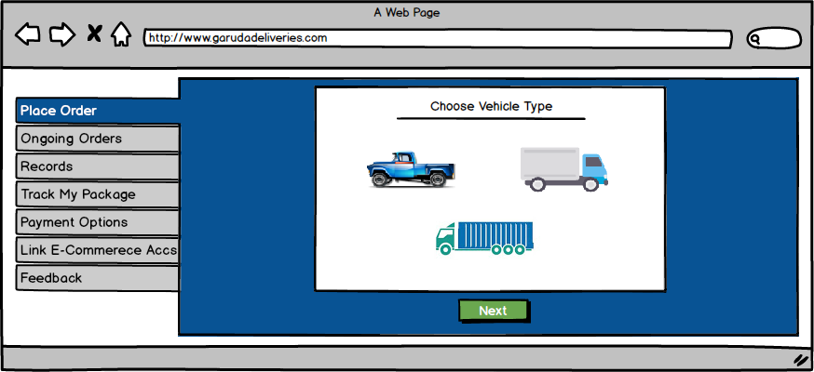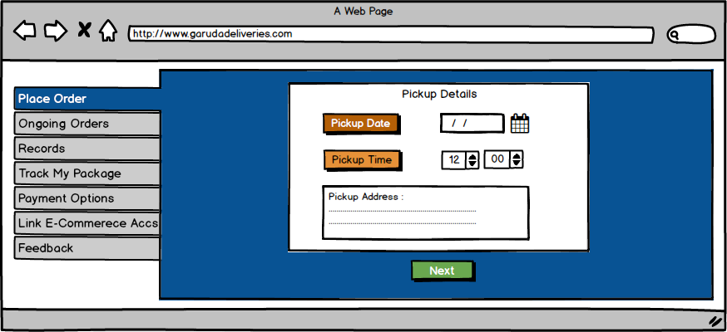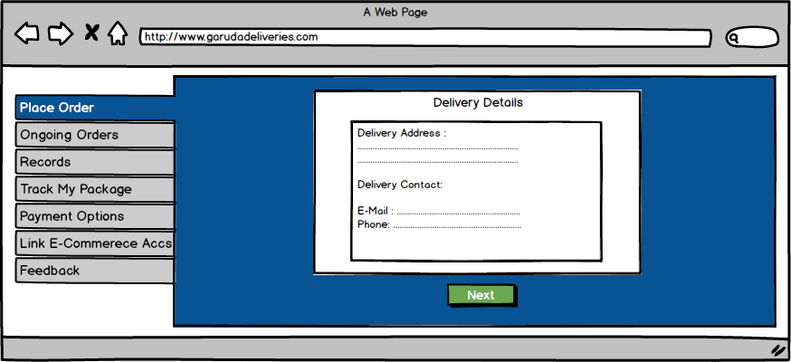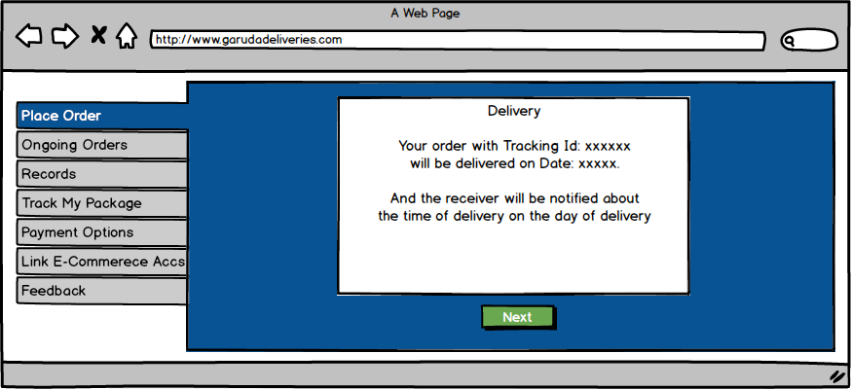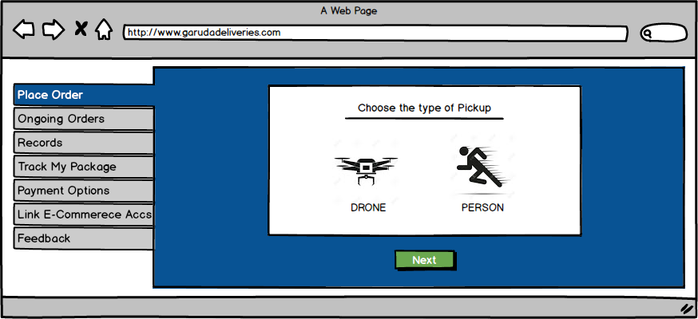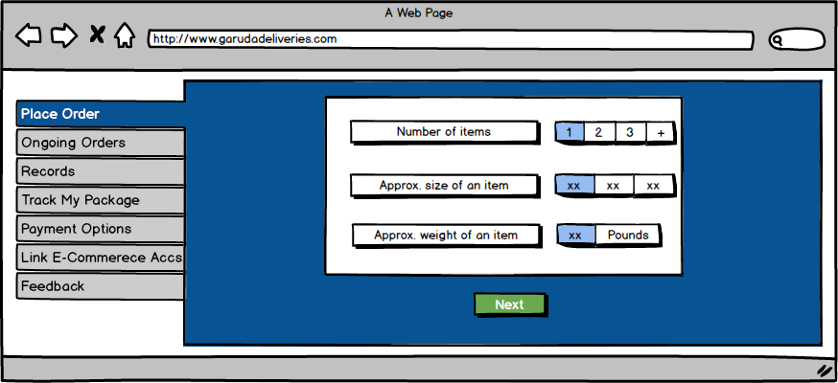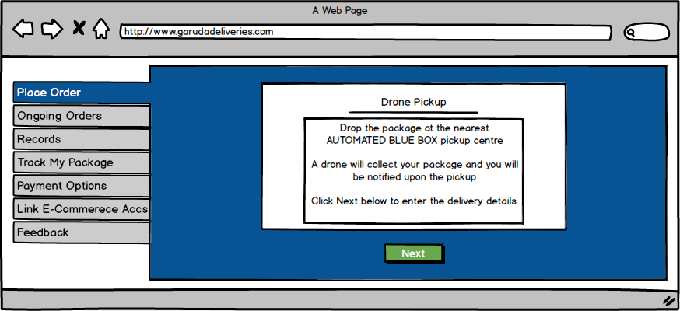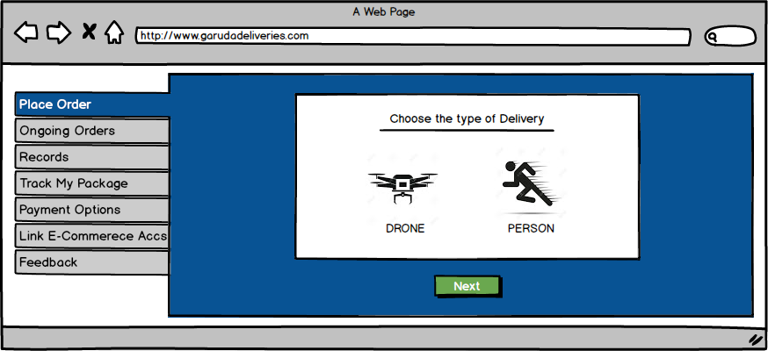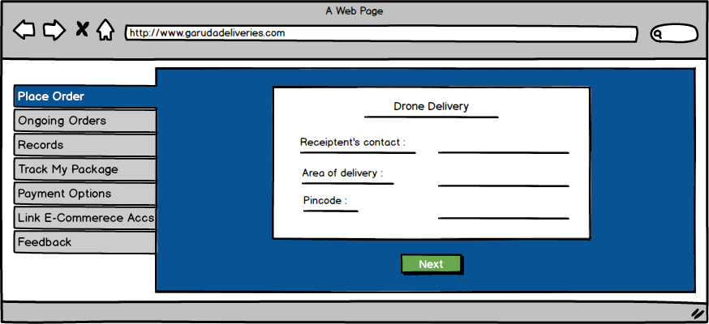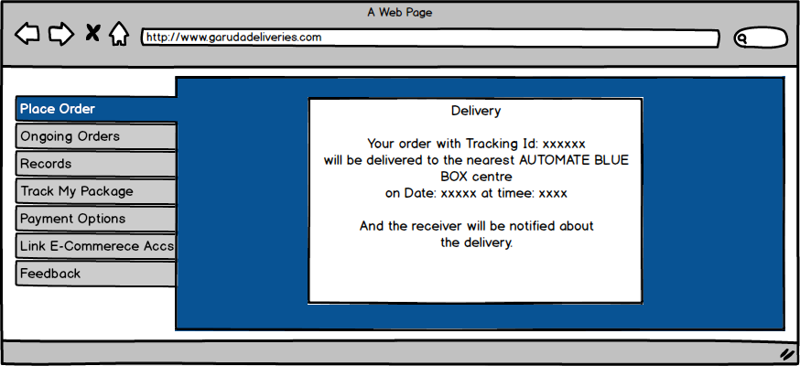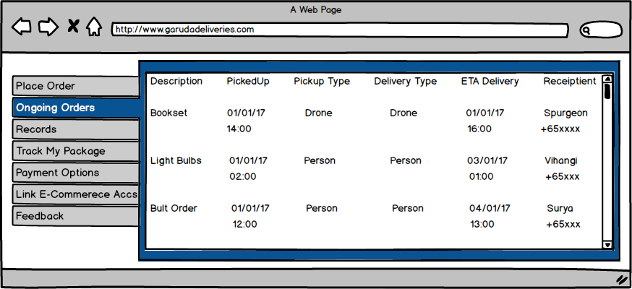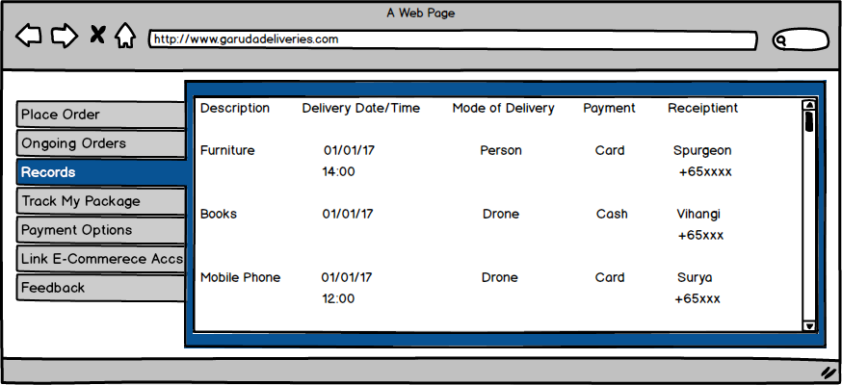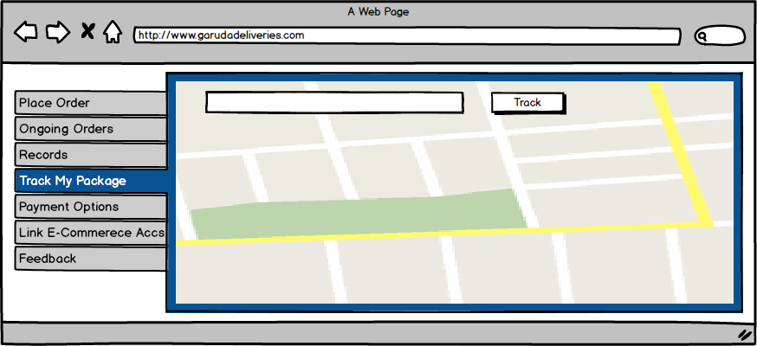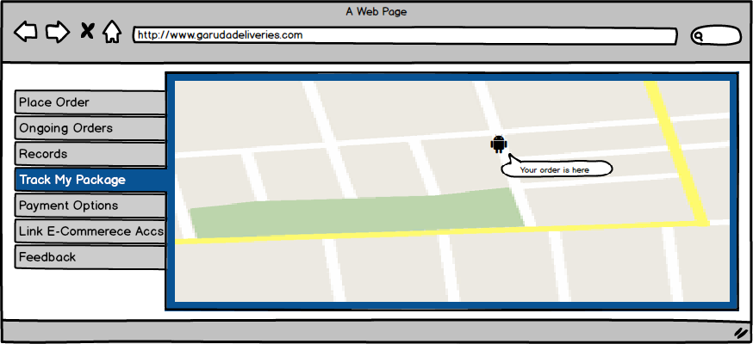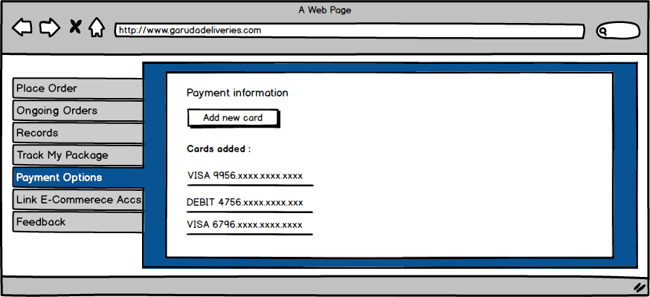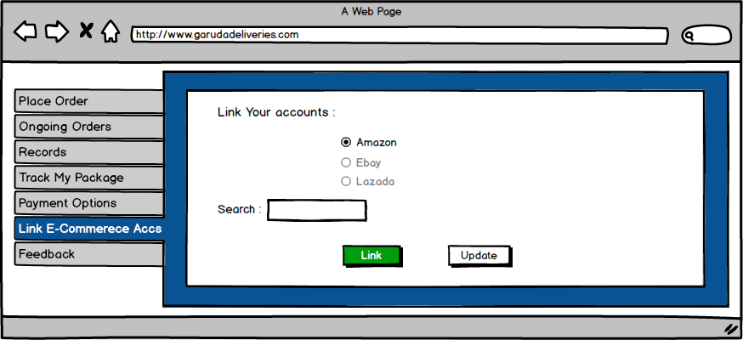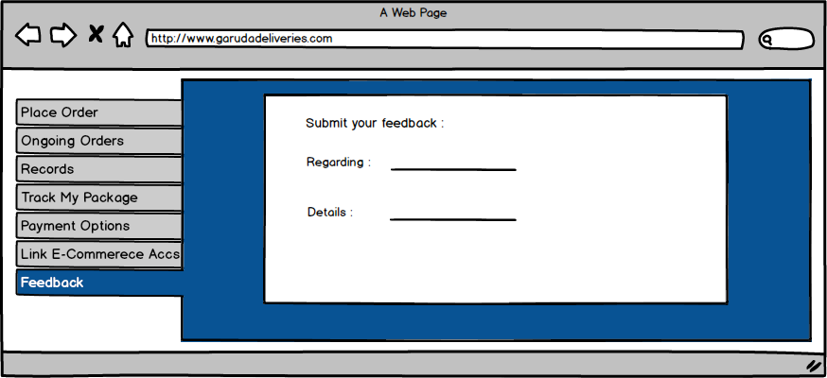

The second iteration was a significant improvement from the first in the overall design of the website. The transformation from paper to digital allowed us to concentrate on the design aspect of the website along with the features we incorporated. Both features and design ere given equal importance during this phase. The significance of the lean UX methods can be emphasized during this phase of project development. As we already have a user tested product, it will reduce the loss of costs in implementing the change from paper to digital. The user testing revealed a few valuable inputs. The users were now analyzing the visual aspects of our website along with the features incorporated within it.

**Testing**

The user testing was done with same users of the first iteration. There are some the points/opinions they shared with us regarding the second prototype. The users were impressed with the design of the website. There are some minor additions which we thought the user wanted in the next iteration. After tracking the package, the user wanted to know where their package is on the map, the exact location. The users also mentioned that they would want to know about the nearest drop off centers for the drone pick up of the package.

***Insights:***

1. The feedback received was very positive. Most of the users seemed to like the design.
2. The small changes mentioned by the users are taken into consideration.
3. “Link E-Commerce Accounts” feature seemed to have provided the linkage for the user to understand how the delivery company works with the e-commerce retailers.
4. The “ongoing orders” and “records” pages were considered to be very informative.
5. The features were very well understood by all the users.

***Changes to the next prototype:***

1. A new location based tracking page showing the location of the package is the added for the better understanding of the “Track my package” feature.
2. A new button is added for letting the user view the nearest drop-off centres for drone pickup in a map view.
3. Refined the entire design again by removing the unnecessary buttons and changing the text input areas to scrollable bars or combo boxes.
4. Changes to the color scheme of some of the pages.

**Some of the things that we would like to add to the insights:**

***What did the participants value the most?***

The participants valued the consideration of faster delivery. The delivery records which listed all the previous transaction and displayed the status of the ongoing order. They also like the approach of tracking the package. The navigation bar was smooth and design was simple and approachable.

***What got them excited?***

The ongoing orders and records page, grabbed the attention of the user. The detailed list down of the orders and all the previous deliveries provided a lot of information the user wants to look at all times.

***What would convince them about the idea?***

The idea about delivering the package on the convenience of the customer and tracking the package would convince the user. The functioning of the delivery service with a detailed list down of the orders and delivery history, along with tracking of the package would clear most of the doubts users have about the delivery and also would gain their confidence in making the bookings.

Moreover the use of new technologies to cut down on shipping costs would make some users curious to consider our delivery service.

The above mentioned changes were added/modified after the second iteration.

**Prototype – Iteration 3**

The users were satisfied with all the features incorporated within the final design of the website.The new color theme got them excited. The use of basic colors that allowed the text to be visible much more clearly was noticed during the user testing.The color scheme used for the “Ongoing Orders” page made it easy to navigate as per the user inputs. The users did not mention any further enhancements to the overall design. However, the team felt that some minor additions can be made with respect to the project. Improving communication between the customer and the retailer can be made through the website itself.Giving the chance for the customers to rate the retailers can also be made in the website. However, our time constraints did not allow us to implement such features in these later stages. We felt that as the basic needs of our product are fulfilled further ideas can be analyzed and implemented in future as per the needs of the users.

**Images of the final prototype:**

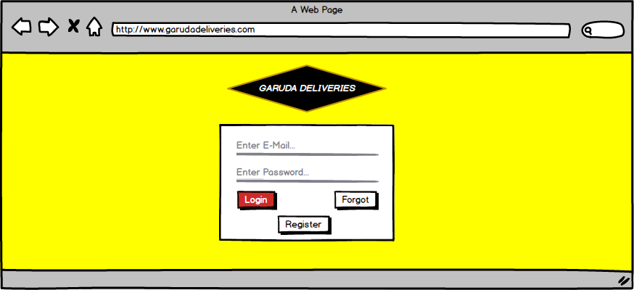

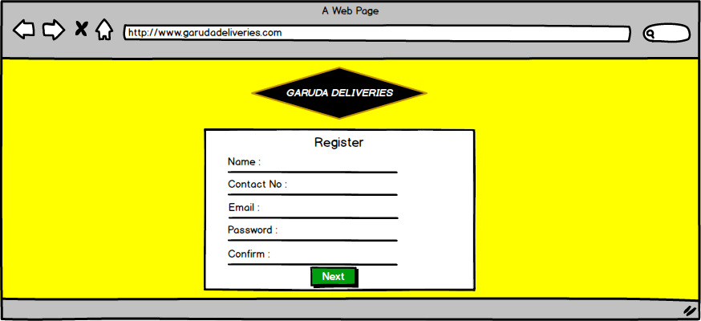

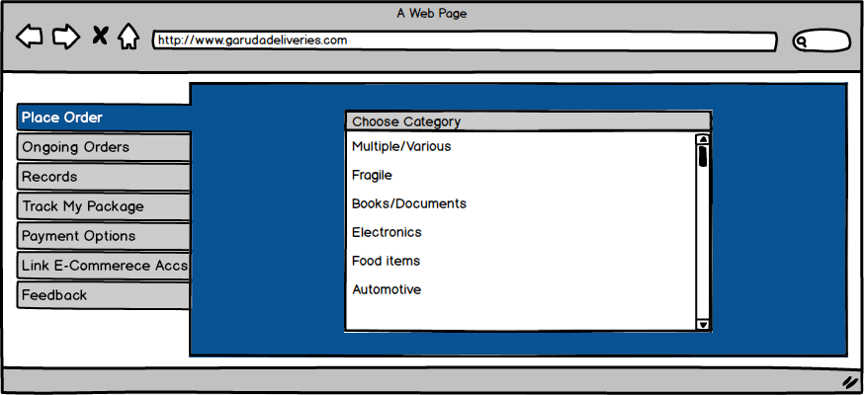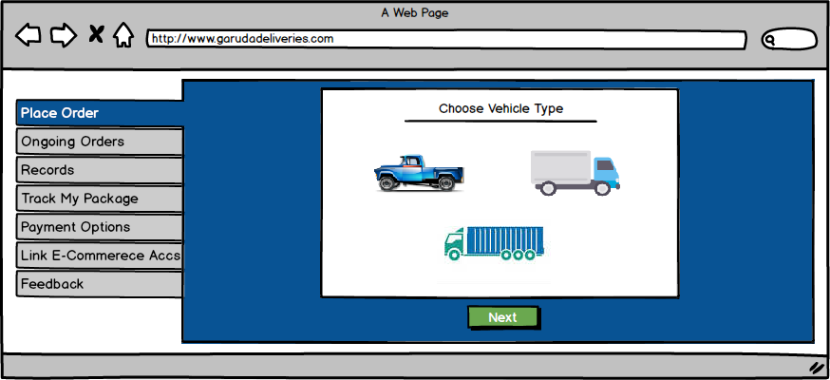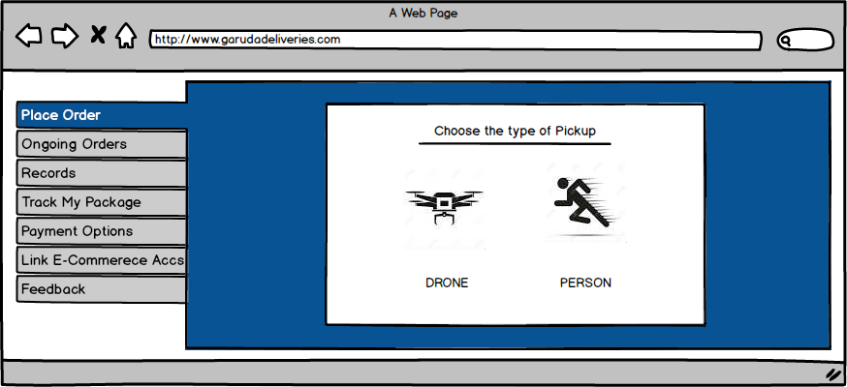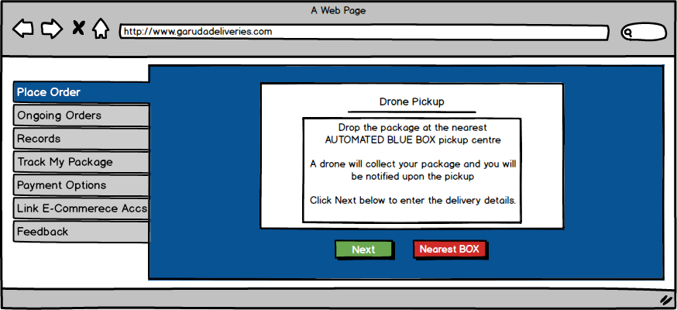

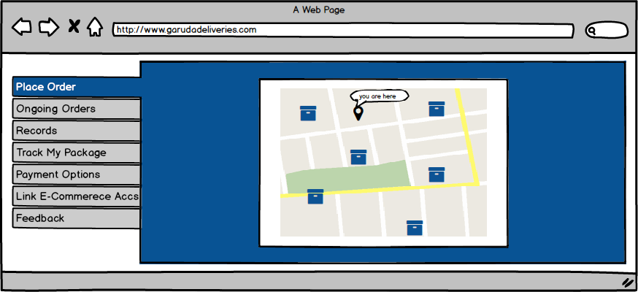

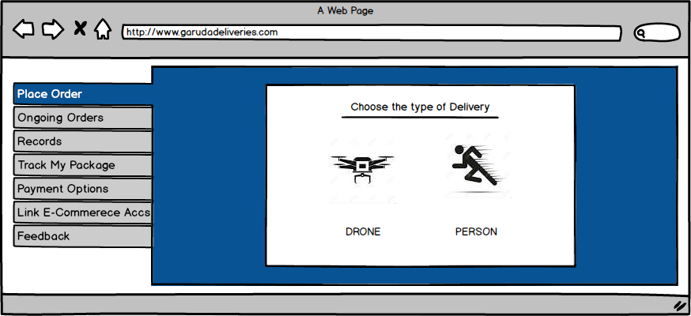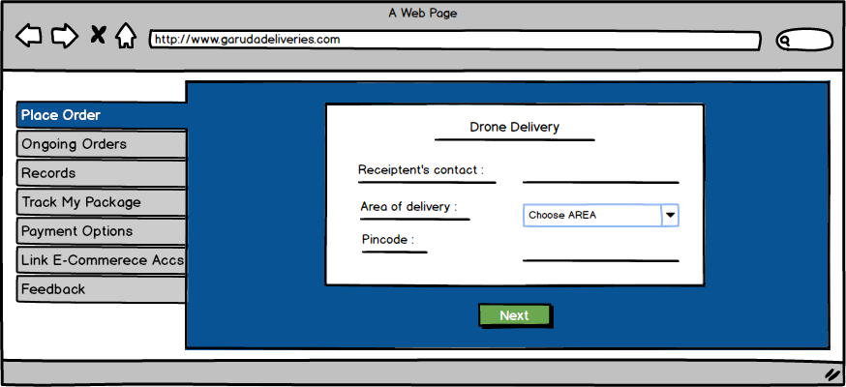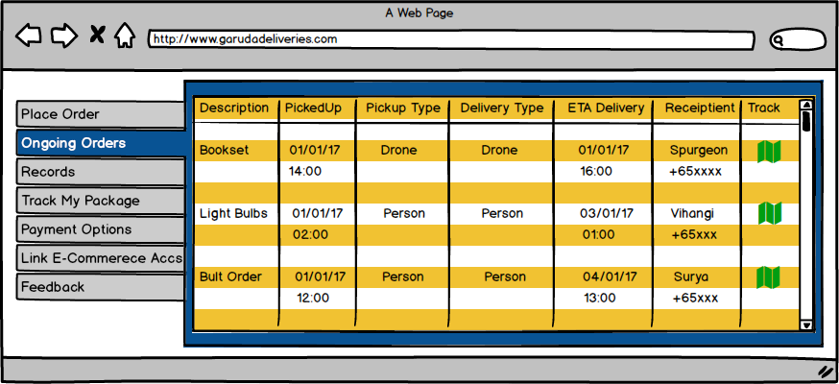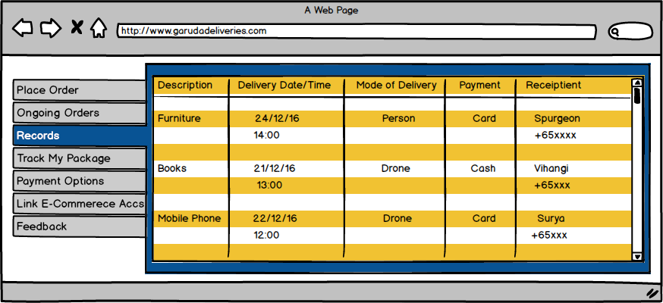

**Lean UX:**

The relevance of lean-UX methods was more evident during the SPRINT because of the time constraints of the whole process.

The lean UX methods used while working on this project made us realize the significance of a proper working method when dealing with different situations. In our case, the lean UX was the most effective method because it had every one of us involved as a team in all the stages of development. And the scale of our project is much smaller. The methods we used to get user feedback was also time saving as we used paper prototypes for the first iteration. Changes were made quickly and drawings were altered.

The main advantage of lean UX is it saves time and resources through constant iterations and review. This was observed while conducting user testing for the three iterations. Since our product was a website, all the users we tested were well aware of its basic usage and were eager to participate and give their suggestions. This Situation made us realize the efficiency of lean UX methods in the current scenario. And we were able to achieve our end goals in quick time.

Furthermore, Lean UX is meant to be a lot of trial and error, and knowing what to do when you fail is a huge part of making the right decisions. Our team needed to understand where we went wrong, have a process for tracking and measuring the feedback, and spend time discussing it with our team — then it is time to start making decisions and repeat the process until we get it right. This kind of trial and error methods were the most crucial part of finishing the project in two days. It helped the team understand the significance of the lean UX methods for startup companies with moderate initial costs and which have to work under certain time constraints. However, this methods may not be entirely successful in the context of bigger projects that involve higher costs.

**Business model:**

We want people to use our cost-effective service, so that we can improve our business and expand our territory.

Our business is a delivery service company that helps the retailers of the e-commerce companies to successfully make their deliveries on time and also save money on the delivery costs.

The delivery service industry now is one of the competently growing industries in the world. Investing in a business like this would highly benefit all the parties involved. We think that with the highly successful scope of the new technologies being introduced into our business, it would disrupt the current delivery service industry sector and also help us gain the lead we need to expand our business.

We ran a number of trails for the whole delivery and perfected our design to make a smooth and seamless delivery. The drone technology introduced was tested numerous amount of times considering all the factors of failure involved from pickup to delivery.

The drones and the pickup and delivery processes will be managed by our efficient and hard working team. Employees will be working on the clock taking shifts to ensure that the service is operating 24/7.

We built and designed our entire business to be cost-effective to the users. Drones are cheap and easy to buy, management of drones is cheaper compared to the vehicles needed for delivery and also saves up time on the delivery. There will no issues of loss of goods and long distances can be covered in a short time. The shipping costs and taxes spent on the delivery of the goods are generally levied on the retailers too, cutting down on such costs with the usage of drones will in turn reduce the extra costs levied on the user. These are only some of the measures we put into play, with successful ventures, more drones will be employed in the future and new technological innovations will be adapted in refining our system.

In conclusion we believe that, advances in new technologies have enabled us to expand our thinking and try out new ways of doing business. We hope to succeed and keep growing.

**Appendix:**

**Interviews:**

***Name*: Kevin**

***Time*: 1.40 Pm**

***Venue*: Classroom**

***Study*: Bachelors in IT**

**Interview questions:**

1) Do you use the internet for your services?

Yes, it is relevant to our business.

2) Do you want your deliveries to be quick? Are you willing to wait for an estimated amount of time for the deliveries to be made?

Yes. Reach the customer as soon as possible. 2-3 days will be acceptable.

3) Is there a need for a faster and reliable service for your delivery?

Yes. Improvements can be made such as proper house address delivery.

4) Is there a need for odd-hour deliveries? Do you get orders for late time deliveries from the customers?

No. It is not a good timing for customers. It is not necessary. 9-10 pm should be the max.

5) Do you want a fixed delivery time for your packages?

Yes, but it demands on the issues.

6) Are there any transportation issues you encounter with the delivery services?

No. There should be no issues.

7) Are there any issues of damaged or lost goods while delivering the products?

There will be damaged goods cases. Lost goods maybe not.

8) Do the services refund you if the goods are damaged or lost? Do they insure your goods?

Yes. Call the retailer for the refund and return the damaged goods/ Return a working product.

9) Do you wish to track the status of the goods while they are delivered to the customers?

Yes. I would know when does the customer received and how do they like it.

10) What is the mode of payment you prefer? Do you want the customers to pay beforehand online or do you give the option to make cash payments?

I prefer online. Pay on delivery, may cause hassle.

11) Do you accept all kinds of currency from your customers?

Online transaction, currency is not an issue.

12) Do you wish to receive feedbacks from your customers?

Yes. To know the quality of the product and delivery.

13) Are you willing to pay the shipping costs for the delivery?

No, it should be a free service.

14) Do you pay the taxes on foreign goods in case of international deliveries?

Yes. Which will be marked in the profit margin.

15) Do you need to make bulk deliveries in a stipulated amount of time?

It might happen. Festive period should have more delivery.

16) Are you interested in using new methods and technologies in delivering your goods, for example use drones for quicker and efficient transfer?

Yes. It is efficient then it should be good.

17) Do you think innovations in technology can make deliveries more cost-effective?

If technology is more effective than drone, then it will be cost-effective.

**Name: Wei Ching**

**Time: 2:00pm**

**Venue: Class**

**Study: Bachelors in IT**

**Interview questions:**

1) Do you use the internet for your services?

Yes, it is a cheaper source.

2) Do you want your deliveries to be quick? Are you willing to wait for an estimated amount of time for the deliveries to be made?

Yes, as it makes the firm more organised and staff would know when to do what.

3) Is there a need for a faster and reliable service for your delivery?

Sometimes when the customer demands.

4) Is there a need for odd-hour deliveries? Do you get orders for late time deliveries from the customers?

No, it will cause hassle.

5) Do you want a fixed delivery time for your packages?

No, it should be on individual parcel based and location.

6) Are there any transportation issues you encounter with the delivery services?

Kind of. If the person is not home, then new arrangements have to be made.

7) Are there any issues of damaged or lost goods while delivering the products?

Not damaged or lost goods but misplaced the goods.

8) Do the services refund you if the goods are damaged or lost? Do they insure your goods?

Yes. Some websites do not do it.

9) Do you wish to track the status of the goods while they are delivered to the customers?

Yes. It is easy to know where it is.

10) What is the mode of payment you prefer? Do you want the customers to pay beforehand online or do you give the option to make cash payments?

Online. Cash payment is hard since people do not carry cash all the time and card payment is secure.

11)Do you accept all kinds of currency from your customers?

Yes it brings more customers.

12) Do you wish to receive feedbacks from your customers?

Yes as it is useful for improvement.

13) Are you willing to pay the shipping costs for the delivery?

Yes, as shipment is not free.

14) Do you pay the taxes on foreign goods in case of international deliveries?

Yes, as per law.

15) Do you need to make bulk deliveries in a stipulated amount of time?

No, it will cause stress in workers.

16) Are you interested in using new methods and technologies in delivering your goods, for example use drones for quicker and efficient transfer?

Yes. But ensure security.

17) Do you think innovations in technology can make deliveries more cost-effective?

Yes, It is part of company development.

**Name: Sanjay kumar**

**Time: 1.30 Pm**

**Venue: C1-04**

**Study: Bachelors in IT**

**Interview questions:**

1) Do you use the internet for your services?

Yes, I would use the internet services as it ensures fast access to data.

2) Do you want your deliveries to be quick? Are you willing to wait for an estimated amount of time for the deliveries to be made?

Yes, and I would wait for an estimated amount of time for the deliveries as it is inevitable.

3) Is there a need for a faster and reliable service for your delivery?

Yes, as customers would prefer to fast.

4) Is there a need for odd-hour deliveries? Do you get orders for late time deliveries from the customers?

No, it would cause problems such as disturbance to the neighbourhood and it would look odd.

5) Do you want a fixed delivery time for your packages?

No. It depends on the individual as they might like it flexible.

6) Are there any transportation issues you encounter with the delivery services?

Yes. Driver issue and vehicle breakdowns.

7) Are there any issues of damaged or lost goods while delivering the products?

Proper maintenance for can rectify.

8) Do the services refund you if the goods are damaged or lost? Do they insure your goods?

Yes. It will increase consumer rate as they will know the source is reliable.

9) Do you wish to track the status of the goods while they are delivered to the customers?

Yes. For the ease of the customers.

10) What is the mode of payment you prefer? Do you want the customers to pay beforehand online or do you give the option to make cash payments?

Online payment. To increase the trust of customer, cash on delivery will be fine.

11) Do you accept all kinds of currency from your customers?

Yes. Credit card money gets converted anyways.

12) Do you wish to receive feedbacks from your customers?

Yes. For the improvement of our service.

13) Are you willing to pay the shipping costs for the delivery?

No. When they order in bulk.

14) Do you pay the taxes on foreign goods in case of international deliveries?

Yes, it cannot be changed.

15) Do you need to make bulk deliveries in a stipulated amount of time?

Yes, if customers wants.

16) Are you interested in using new methods and technologies in delivering your goods, for example use drones for quicker and efficient transfer?

Yes, but advanced technology such as drone I think will look weird.

17) Do you think innovations in technology can make deliveries more cost-effective?

Yes. Investment is good.

**Secondary research references:**

**http://www.straitstimes.com/business/firm-soars-ahead-with-drone-technology**

[**https://www.lalamove.com/**](https://www.lalamove.com/)

[**https://www.amazon.com/slp/drone-technology/4ubbmzpmn48c7nn**](https://www.amazon.com/slp/drone-technology/4ubbmzpmn48c7nn)

**https://www.retail.org.sg/**

**Evidence of the work done by the group during the SPRINT**



